Compilation steps and compiler
https://iamparv.wordpress.com/2013/04/16/compiler-design-program-compilation-steps-explained/

SDLC
SDLC, Software Development Life Cycle is a process used by software industry to design, develop and test high quality softwares that meets or exceeds customer expectations, reaches completion within times and cost estimates.
The software development life cycle (SDLC) is a framework defining tasks performed at each step in the software development process.
ISO/IEC 12207 is an international standard for software life-cycle processes. It aims to be the standard that defines all the tasks required for developing and maintaining software.
Popular SDLC models: Waterfall, Iterative, Spiral, V, Big-Bang, Agile, RAD, Software prototyping,
Waterfall Model:
Waterfall was one of the earliest models that soon came into existence after SDLC approach was introduced. Also known as linear sequential life cycle model, this model is employed in projects where the second phase starts only at the completion of first phase and so on. Most companies utilize this model for small projects that has realistic goals and expectations. After the accomplishment of each phase a review is carried out to check on bugs and errors.
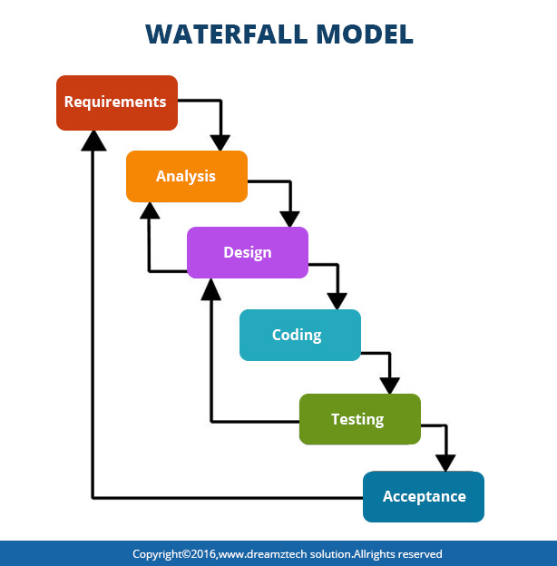
Incremental model:
With a bit confusing look, but a simple concept, incremental model helps projects to move towards excellence and perfection in a slow yet effective pace. The project gets categorized into multiple builds. Each build follows the waterfall cycle that has been discussed in Point 1. Each module has design, development, testing and implementation phase for an assigned code. This model is best for projects that have multiple modules. 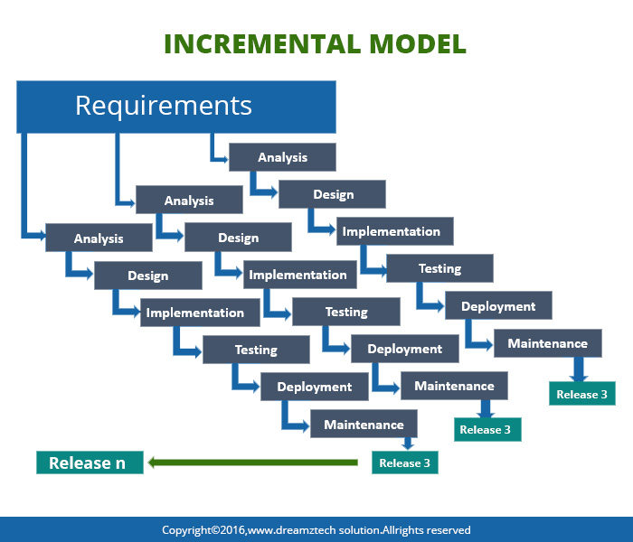

Agile Model: Agile thought process had started early in the software development and started becoming popular with time due to its flexibility and adaptability.
The most popular agile methods include Rational Unified Process (1994), Scrum (1995), Adaptive Software Development, etc. These are now collectively referred to as agile methodologies, after the Agile Manifesto was published in 2001.
Here is a graphical illustration of the Agile Model:
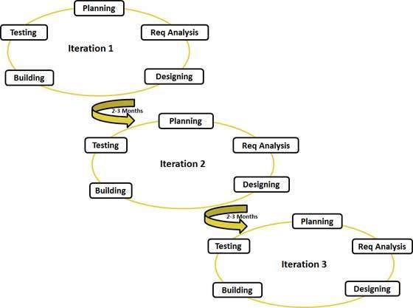
Following are the Agile Manifesto principles
- Individuals and interactions . In agile development, self-organization and motivation are important, as are interactions like co-location and pair programming.
- Working software . Demo working software is considered the best means of communication with the customer to understand their requirement, instead of just depending on documentation.
- Customer collaboration . As the requirements cannot be gathered completely in the beginning of the project due to various factors, continuous customer interaction is very important to get proper product requirements.
- Responding to change . agile development is focused on quick responses to change and continuous development.

